**FCFS Scheduling-**

In FCFS Scheduling,

* The process which arrives first in the ready queue is firstly assigned the CPU.
* In case of a tie, process with smaller process id is executed first.
* It is always non-preemptive in nature.

**Advantages-**

* It is simple and easy to understand.
* It can be easily implemented using queue data structure.
* It does not lead to starvation.

**Disadvantages-**

* It does not consider the priority or burst time of the processes.
* It suffers from **convoy effect**.

|  |
| --- |
| **Convoy Effect**  In convoy effect,   * Consider processes with higher burst time arrived before the processes with smaller burst time. * Then, smaller processes have to wait for a long time for longer processes to release the CPU. |

**PRACTICE PROBLEMS BASED ON FCFS SCHEDULING-**

**Problem-01:**

Consider the set of 5 processes whose arrival time and burst time are given below-

|  |  |  |
| --- | --- | --- |
| **Process Id** | **Arrival time** | **Burst time** |
| P1 | 3 | 4 |
| P2 | 5 | 3 |
| P3 | 0 | 2 |
| P4 | 5 | 1 |
| P5 | 4 | 3 |

If the CPU scheduling policy is FCFS, calculate the average waiting time and average turn around time.

**Solution-**

**Gantt Chart-**

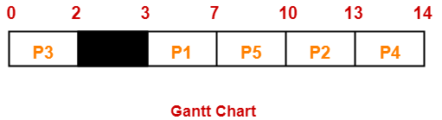

Here, black box represents the idle time of CPU.

Now, we know-

* Turn Around time = Exit time – Arrival time
* Waiting time = Turn Around time – Burst time

|  |  |  |  |
| --- | --- | --- | --- |
| **Process Id** | **Exit time** | **Turn Around time** | **Waiting time** |
| P1 | 7 | 7 – 3 = 4 | 4 – 4 = 0 |
| P2 | 13 | 13 – 5 = 8 | 8 – 3 = 5 |
| P3 | 2 | 2 – 0 = 2 | 2 – 2 = 0 |
| P4 | 14 | 14 – 5 = 9 | 9 – 1 = 8 |
| P5 | 10 | 10 – 4 = 6 | 6 – 3 = 3 |

Now,

* Average Turn Around time = (4 + 8 + 2 + 9 + 6) / 5 = 29 / 5 = 5.8 unit
* Average waiting time = (0 + 5 + 0 + 8 + 3) / 5 = 16 / 5 = 3.2 unit

**Problem-02:**

Consider the set of 3 processes whose arrival time and burst time are given below-

|  |  |  |
| --- | --- | --- |
| **Process Id** | **Arrival time** | **Burst time** |
| P1 | 0 | 2 |
| P2 | 3 | 1 |
| P3 | 5 | 6 |

If the CPU scheduling policy is FCFS, calculate the average waiting time and average turn around time.

**Solution-**

**Gantt Chart-**

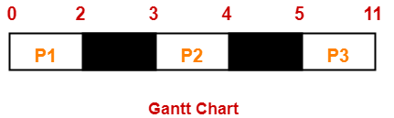

Here, black box represents the idle time of CPU.

Now, we know-

* Turn Around time = Exit time – Arrival time
* Waiting time = Turn Around time – Burst time

|  |  |  |  |
| --- | --- | --- | --- |
| **Process Id** | **Exit time** | **Turn Around time** | **Waiting time** |
| P1 | 2 | 2 – 0 = 2 | 2 – 2 = 0 |
| P2 | 4 | 4 – 3 = 1 | 1 – 1 = 0 |
| P3 | 11 | 11- 5 = 6 | 6 – 6 = 0 |

Now,

* Average Turn Around time = (2 + 1 + 6) / 3 = 9 / 3 = 3 unit
* Average waiting time = (0 + 0 + 0) / 3 = 0 / 3 = 0 unit

**Problem-03:**

Consider the set of 6 processes whose arrival time and burst time are given below-

|  |  |  |
| --- | --- | --- |
| **Process Id** | **Arrival time** | **Burst time** |
| P1 | 0 | 3 |
| P2 | 1 | 2 |
| P3 | 2 | 1 |
| P4 | 3 | 4 |
| P5 | 4 | 5 |
| P6 | 5 | 2 |

If the CPU scheduling policy is FCFS and there is 1 unit of overhead in scheduling the processes, find the efficiency of the algorithm.

**Solution-**

**Gantt Chart-**

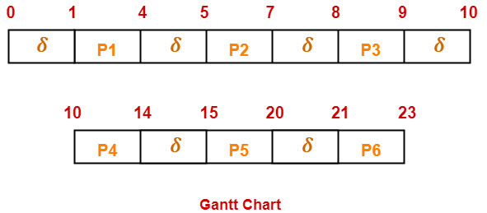

Here, δ denotes the context switching overhead.

Now,

* Useless time / Wasted time = 6 x δ = 6 x 1 = 6 unit
* Total time = 23 unit
* Useful time = 23 unit – 6 unit = 17 unit

Efficiency (η)

= Useful time / Total Total

= 17 unit / 23 unit

= 0.7391

= 73.91%

**SJF Scheduling-**

In SJF Scheduling,

* Out of all the available processes, CPU is assigned to the process having smallest burst time.
* In case of a tie, it is broken by [**FCFS Scheduling**](https://www.gatevidyalay.com/first-come-first-serve-cpu-scheduling/).

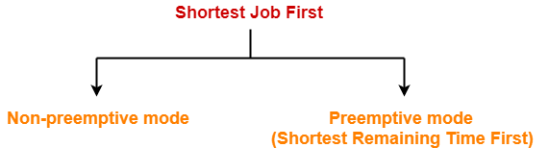

* SJF Scheduling can be used in both preemptive and non-preemptive mode.
* Preemptive mode of Shortest Job First is called as **Shortest Remaining Time First (SRTF)**.

**Advantages-**

* SRTF is optimal and guarantees the minimum average waiting time.
* It provides a standard for other algorithms since no other algorithm performs better than it.

**Disadvantages-**

* It can not be implemented practically since burst time of the processes can not be known in advance.
* It leads to starvation for processes with larger burst time.
* Priorities can not be set for the processes.
* Processes with larger burst time have poor response time.

**PRACTICE PROBLEMS BASED ON SJF SCHEDULING-**

**Problem-01:**

Consider the set of 5 processes whose arrival time and burst time are given below-

|  |  |  |
| --- | --- | --- |
| **Process Id** | **Arrival time** | **Burst time** |
| P1 | 3 | 1 |
| P2 | 1 | 4 |
| P3 | 4 | 2 |
| P4 | 0 | 6 |
| P5 | 2 | 3 |

If the CPU scheduling policy is SJF non-preemptive, calculate the average waiting time and average turn around time.

**Solution-**

**Gantt Chart-**

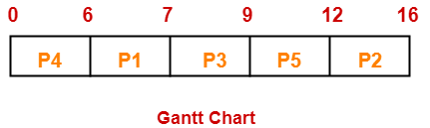

Now, we know-

* Turn Around time = Exit time – Arrival time
* Waiting time = Turn Around time – Burst time

|  |  |  |  |
| --- | --- | --- | --- |
| **Process Id** | **Exit time** | **Turn Around time** | **Waiting time** |
| P1 | 7 | 7 – 3 = 4 | 4 – 1 = 3 |
| P2 | 16 | 16 – 1 = 15 | 15 – 4 = 11 |
| P3 | 9 | 9 – 4 = 5 | 5 – 2 = 3 |
| P4 | 6 | 6 – 0 = 6 | 6 – 6 = 0 |
| P5 | 12 | 12 – 2 = 10 | 10 – 3 = 7 |

Now,

* Average Turn Around time = (4 + 15 + 5 + 6 + 10) / 5 = 40 / 5 = 8 unit
* Average waiting time = (3 + 11 + 3 + 0 + 7) / 5 = 24 / 5 = 4.8 unit

**Problem-02:**

Consider the set of 5 processes whose arrival time and burst time are given below-

|  |  |  |
| --- | --- | --- |
| **Process Id** | **Arrival time** | **Burst time** |
| P1 | 3 | 1 |
| P2 | 1 | 4 |
| P3 | 4 | 2 |
| P4 | 0 | 6 |
| P5 | 2 | 3 |

If the CPU scheduling policy is SJF preemptive, calculate the average waiting time and average turnaround time.

**Solution-**

**Gantt Chart-**

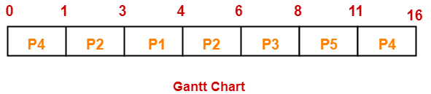

Now, we know-

* Turn Around time = Exit time – Arrival time
* Waiting time = Turn Around time – Burst time

|  |  |  |  |
| --- | --- | --- | --- |
| **Process Id** | **Exit time** | **Turn Around time** | **Waiting time** |
| P1 | 4 | 4 – 3 = 1 | 1 – 1 = 0 |
| P2 | 6 | 6 – 1 = 5 | 5 – 4 = 1 |
| P3 | 8 | 8 – 4 = 4 | 4 – 2 = 2 |
| P4 | 16 | 16 – 0 = 16 | 16 – 6 = 10 |
| P5 | 11 | 11 – 2 = 9 | 9 – 3 = 6 |

Now,

* Average Turn Around time = (1 + 5 + 4 + 16 + 9) / 5 = 35 / 5 = 7 unit
* Average waiting time = (0 + 1 + 2 + 10 + 6) / 5 = 19 / 5 = 3.8 unit

**Problem-03:**

Consider the set of 6 processes whose arrival time and burst time are given below-

|  |  |  |
| --- | --- | --- |
| **Process Id** | **Arrival time** | **Burst time** |
| P1 | 0 | 7 |
| P2 | 1 | 5 |
| P3 | 2 | 3 |
| P4 | 3 | 1 |
| P5 | 4 | 2 |
| P6 | 5 | 1 |

If the CPU scheduling policy is shortest remaining time first, calculate the average waiting time and average turn around time.

**Solution-**

**Gantt Chart-**

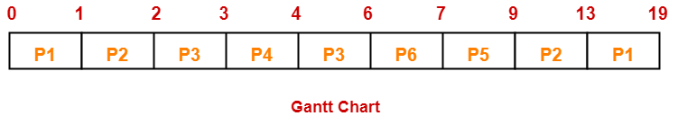

Now, we know-

* Turn Around time = Exit time – Arrival time
* Waiting time = Turn Around time – Burst time

|  |  |  |  |
| --- | --- | --- | --- |
| **Process Id** | **Exit time** | **Turn Around time** | **Waiting time** |
| P1 | 19 | 19 – 0 = 19 | 19 – 7 = 12 |
| P2 | 13 | 13 – 1 = 12 | 12 – 5 = 7 |
| P3 | 6 | 6 – 2 = 4 | 4 – 3 = 1 |
| P4 | 4 | 4 – 3 = 1 | 1 – 1 = 0 |
| P5 | 9 | 9 – 4 = 5 | 5 – 2 = 3 |
| P6 | 7 | 7 – 5 = 2 | 2 – 1 = 1 |

Now,

* Average Turn Around time = (19 + 12 + 4 + 1 + 5 + 2) / 6 = 43 / 6 = 7.17 unit
* Average waiting time = (12 + 7 + 1 + 0 + 3 + 1) / 6 = 24 / 6 = 4 unit

**Problem-04:**

Consider the set of 3 processes whose arrival time and burst time are given below-

|  |  |  |
| --- | --- | --- |
| **Process Id** | **Arrival time** | **Burst time** |
| P1 | 0 | 9 |
| P2 | 1 | 4 |
| P3 | 2 | 9 |

If the CPU scheduling policy is SRTF, calculate the average waiting time and average turn around time.

**Solution-**

**Gantt Chart-**

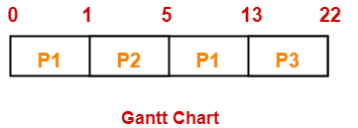

Now, we know-

* Turn Around time = Exit time – Arrival time
* Waiting time = Turn Around time – Burst time

|  |  |  |  |
| --- | --- | --- | --- |
| **Process Id** | **Exit time** | **Turn Around time** | **Waiting time** |
| P1 | 13 | 13 – 0 = 13 | 13 – 9 = 4 |
| P2 | 5 | 5 – 1 = 4 | 4 – 4 = 0 |
| P3 | 22 | 22- 2 = 20 | 20 – 9 = 11 |

Now,

* Average Turn Around time = (13 + 4 + 20) / 3 = 37 / 3 = 12.33 unit
* Average waiting time = (4 + 0 + 11) / 3 = 15 / 3 = 5 unit

**Problem-05:**

Consider the set of 4 processes whose arrival time and burst time are given below-

|  |  |  |
| --- | --- | --- |
| **Process Id** | **Arrival time** | **Burst time** |
| P1 | 0 | 20 |
| P2 | 15 | 25 |
| P3 | 30 | 10 |
| P4 | 45 | 15 |

If the CPU scheduling policy is SRTF, calculate the waiting time of process P2.

**Solution-**

**Gantt Chart-**

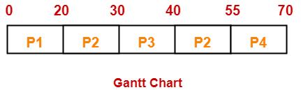

Now, we know-

* Turn Around time = Exit time – Arrival time
* Waiting time = Turn Around time – Burst time

Thus,

* Turn Around Time of process P2 = 55 – 15 = 40 unit
* Waiting time of process P2 = 40 – 25 = 15 unit